PROJECT FINAL REVIEW

TITLE: Volatility Regime Clustering and Its Impact on Portfolio Diversification

Submitted by

DAPHNI MICHELLE B , 22MIA1159
SREE DARSHNE J , 22MIA1167

SUJANA S, 22MIA1142

MGT1060 – RISK AND FRAUD ANALYTICS

INTEGRATED MTECH COMPUTER SCIENCE ENGINEERING WITH SPECIALIZATION IN BUSINESS ANALYTICS.



VIT CHENNAI
VANDALUR – KELAMBAKKAM ROAD CHENNAI – 600
1. Introduction
In any empirical research study, alignment between the objective, methodology, results, validity, and implications is essential to ensure consistency, logical flow, and academic rigor. A well-aligned research framework ensures that the chosen methods effectively address the research problem, the results directly respond to the objectives, and the conclusions drawn are both valid and meaningful. In this study on volatility regime clustering and its impact on portfolio diversification, each component is carefully structured to support and reinforce the others. This alignment not only strengthens the credibility of the research but also enhances its practical applicability in financial decision-making and risk management.
Objective
The main objective of this study is to understand how volatility regime clustering influences portfolio diversification and overall investment risk. Instead of assuming that market risk remains constant, this research focuses on identifying different market conditions—such as stable, transitional, and highly volatile periods—and examining how portfolios behave in each of these states.
The study also aims to compare traditional static portfolio strategies with more adaptive, regime-aware approaches to determine whether adjusting investments based on market conditions can improve performance and reduce risk.
METHODOLOGY

Research Framework

In this study, we use a well-structured and systematic analytical framework to study the effect of volatility regime clustering on portfolio diversification. The financial markets are fluid, and therefore, relevant and precise analysis should consider both the temporal and structural variation in risk. Based on this assumption, this paper is presented within a multi-stage framework that combines theory with empirics.
The analysis process involves different stages. Firstly, data collection and pre-processing are done to obtain high quality data. Secondly, the volatility is estimated by using statistical models to model the time-varying risk. Thirdly, clustering algorithms are employed to identify regimes from the earlier obtained time series. Portfolio construction strategies are then designed for each identified regime. Lastly, the strategies are valued to examine how well the strategies work in different regimes.
Besides the empirical pipeline, the paper uses the Systematic Literature Review (SLR) framework. In this way, the research is supported both on the existing literature on diversification and on a previously identified research gap. Giving the combination of synthesis of theory and empirical validation, the framework allows for a better understanding of diversification under regime-dependent market behaviour.

Systematic Literature Review Framework

To strengthen the theoretical framework of the study, a systematic literature review (SLR) is carried out. A systematic literature review is a rigorous form of narrative review whose methodology is transparent, explicit and reproducible allowing each stage of the review to be properly assessed. Such method of review allows the paper to meet the academic standards and to place the findings in the context of new advances in financial modelling and machine learning.

Locating Studies

How the papers are found will be by doing a comprehensive search in a wide variety of academic databases to cover the research area thoroughly. Databases used in such searches are Google Scholar, SSRN, ScienceDirect, and IEEE Xplore.
In the above, the key search queries consist of the following: 'volatility clustering', 'regime detection', 'portfolio diversification', 'correlation breakdown' and 'machine learning in finance'. Our searches were not bound to a particular date range but there was a particular focus on newer research (from 2022-2026).
Backward and forward citation tracking, in which papers relevant to the set of key papers are selected for inclusion, is also used to search out defining papers and recent papers addressing the same subject. This guarantees that older theories and experiments will play a role in the literature review. The purpose is to bring together a broader pool of papers that represent development in the application of volatility modelling and diversification.

Study Selection and Evaluation

After the first selection of studies is established, a procedure of selection is carried out. The selected studies are then filtered based on predetermined inclusion criteria. These to ensure the most relevant and reliable studies are selected in line with the purpose of the study.
The criterion for studies selection is that the study focuses on volatility clustering, regime detection or portfolio diversification and contain an empirical or quantitative analysis. Clustering, econometric and machine learning models applied on financial data are especially targeted. On the other hand, no theoretical study is considered if it contains no empirical support and no study of financial risk or portfolio management.
The criteria to be scored include the soundness of the methodology, accuracy/appropriateness of data and appropriateness of the application of the model for the research questions. We also consider the clarity of the modelling approach, strength of the results, and the use of performance measures. This scoring process contributes to a complete and credible literature review.

Analysis and Synthesis of Findings

The chosen studies are critically examined, summarized and systematized in thematic clusters to recognize general trends and main contributions. Prominent categories comprise volatility modelling procedures, regime detection approaches, correlation behaviour and portfolio diversification.
Finally, by summarizing the results of the previous studies, it appears that clustering of volatilities is a robust, widespread process, observable in every financial market and time scale. As volatility increases, correlation between stocks rise, reducing own diversification capabilities. Standard models cannot replicate the empirical evidence.
In addition, recent studies would emphasize the increasingly importance of machine learning techniques, especially the clustering methods to detect regime changes. They serve as more flexible and data driven alternatives of certain econometric models in capturing the true nature of market. Ultimately, this analysis highlights the pitfalls of static portfolio strategies.

Reporting and Use of Results

The literature review findings are incorporated in the empirical design in an orderly fashion. The selection of clustering algorithms, calculation of rolling-window performance measures is implemented based on the literature review. The reporting process provides a means of indicating how the theoretical work can be explicitly linked to how something might work in practice. The relationship between research design and existing approaches together with the accommodation of the different gaps identified by the work enables this.

Data Collection and Preprocessing

The empirical results are built upon historical financial data covering the period from 2006 to 2023. This timeframe is used to observe different market phases, including bull markets-crisis, and bull market recovery. The data comprise daily closing prices for a set of assets/mutual funds. The data preprocessing process is very important. First, missing values are interpolated or simply removed from the data. Next, standardization of asset prices is performed. Logarithmic returns are then calculated, to achieve normality. Finally, asset prices are normalized.
Volatility Estimation

Volatility is estimated using a rolling-window approach, which allows for the capture of time-varying risk dynamics. Unlike static measures, rolling volatility reflects the evolving nature of financial markets, making it particularly suitable for identifying clustering behaviour.
$$σ_{t}=\sqrt{\frac{1}{n}\sum_{i=1}^{n}{(}r_{i}-\overset{ˉ}{r})^{2}}$$
This formulation measures the dispersion of returns around their mean within a specified window. By continuously updating the calculation over time, the method provides a dynamic representation of market risk. This enables the identification of periods characterized by elevated or subdued volatility, which form the basis for regime classification.

Volatility Regime Detection

Volatility regime is the detection of various volatility regimes has been achieved using a variety of clustering techniques on the estimated volatility series. This technique involves classifying observations into different regimes based on their characteristics.
Methods used to partition the data include K-Means clustering, Gaussian Mixture Models (GMM) and change-point detection. The data is partitioned into three regimes: low, medium and high volatility regimes. Each of the regimes has different statistical properties (e.g. variance, skewness and correlation structure). Clustering procedures allow identifying regimes, through an approach not based on arbitrary restrictions, leading to a more general and better representation of the market as observed in data.

Portfolio Construction

The type of two portfolio construction methodologies is offered to assess whether the investor considers the different regime information. Conventional portfolio relies on mean variance optimization that assumes of stable correlations and risks. Since this method is widely accepted, therefore its lack in capturing changing market climates should be noted.
Differ only in exploiting the regime identification, in the regime-aware portfolio the general allocation is, instead of adopting a fixed asset weight, dynamically adapted to the regime related to the current markets. When a high-volatility regime is detected, a reduction in risk exposure and an increased diversification over separated clusters takes place.

Performance Evaluation

Quantitative measures of risk and performance are used to assess the performance of portfolios. Measures of risk or portfolio variance are adopted to present the overall risk of the portfolios. Risk-adjusted return is measure by the Sharpe ratios. Maximum drawdown is used to present downside risk and correlation matrix examination is used to study the inter-asset regime switching relations. An assessment of the effectiveness of diversification is derived by examining these measures for each of the volatility regimes.

Rolling Window Analysis

The data is divided into two periods using a rolling-window approach, to reflect the changing investment environment in the real world. The formation window (used to estimate volatility and regimes) and the evaluation window (which considers the performance of portfolios) are identified so that the research is conducted 'out of sample' thus preventing the future receipt of information.

RESULTS

Overview of Empirical Findings

This section presents a comprehensive empirical evaluation of volatility regime clustering and its impact on portfolio diversification and risk dynamics. The results are derived from a multi-stage analytical pipeline involving rolling volatility estimation, clustering-based regime identification, correlation structure analysis, and portfolio performance evaluation.
The objective of this section is not merely to report numerical outputs but to interpret the results in the context of financial theory and real-world market behaviour. Specifically, the findings aim to address the research questions related to regime-dependent diversification, correlation dynamics, and the effectiveness of adaptive portfolio strategies.
The results are organized into five key components: (i) volatility behaviour over time, (ii) regime classification, (iii) correlation structure across regimes, (iv) portfolio performance comparison, and (v) risk metrics analysis.

Volatility Estimation and Market Behaviour

The rolling 30-day volatility analysis provides strong empirical evidence of time-varying risk in financial markets. The observed volatility pattern is characterized by prolonged periods of stability interrupted by sharp spikes corresponding to major economic disruptions.
Between 2012 and 2019, volatility remains relatively low and stable, indicating favourable market conditions with limited uncertainty. However, a dramatic increase in volatility is observed around 2020, corresponding to the global financial shock caused by the COVID-19 pandemic. This spike represents one of the most significant deviations in the dataset, highlighting the impact of systemic shocks on market risk.
Following this period, volatility gradually declines but does not fully return to pre-crisis levels, suggesting a structural shift in market dynamics.
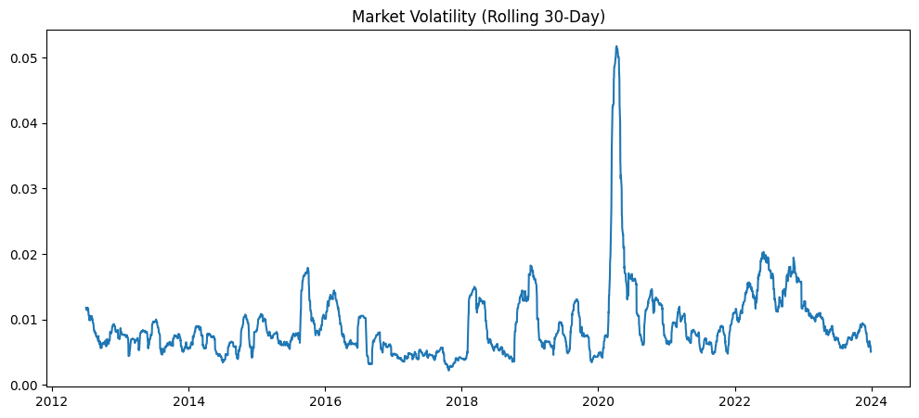
Fig.1. Market Volatility
The persistence of high-volatility periods following major shocks provides clear evidence of volatility clustering, a well-documented phenomenon in financial econometrics. This indicates that risk is not randomly distributed over time but instead follows structured patterns. Such behaviour challenges the assumptions of constant volatility underlying traditional portfolio models and reinforces the need for regime-based analysis

Volatility Regime Clustering Results

The application of clustering techniques to the volatility series resulted in the identification of three distinct market regimes: low, medium, and high volatility. Each regime represents a structurally different state of the market, characterized by unique statistical properties.
The low-volatility regime dominates the dataset, reflecting periods of economic stability and predictable market behaviour. The medium-volatility regime appears as a transitional state, often preceding or following high-volatility episodes. The high-volatility regime, although less frequent, is concentrated around major market disruptions and is associated with extreme fluctuations.
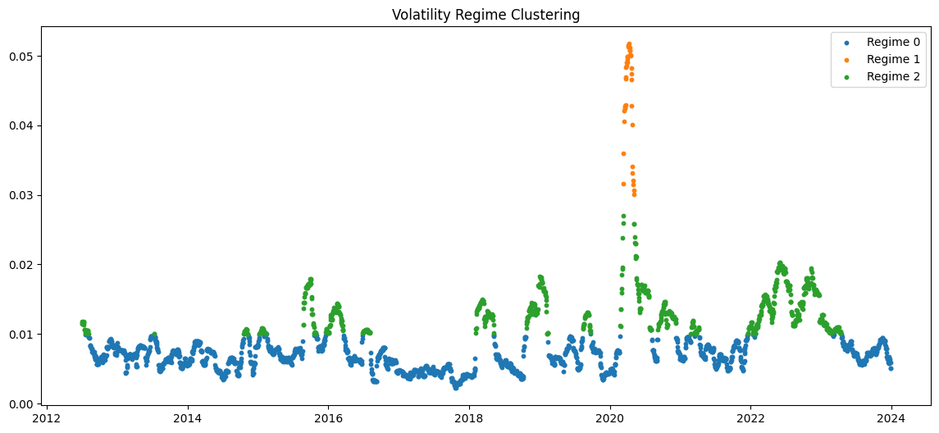
Fig.2. Volatility Regime Clustering
Key Observations:
- Regime transitions are not abrupt but occur gradually, indicating evolving market conditions
- High-volatility regimes are temporally clustered around crisis events
- Medium regimes act as buffers between stable and unstable market states
The clustering results confirm that financial markets operate within discrete regimes rather than a continuous spectrum of volatility. This has important implications for risk modelling, as it suggests that a single model cannot adequately capture market behaviour across all conditions. Instead, adaptive models that respond to regime shifts are required.

Correlation Analysis Across Volatility Regimes

A central objective of this study is to examine how correlations between assets vary across volatility regimes and how this affects diversification effectiveness. The correlation matrices provide valuable insights into the structural behaviour of asset relationships under different market conditions.

Low Volatility Regime

During periods of low volatility, correlations between assets are generally moderate, ranging approximately between 0.2 and 0.6. This indicates that assets exhibit relatively independent movement, allowing for effective diversification.
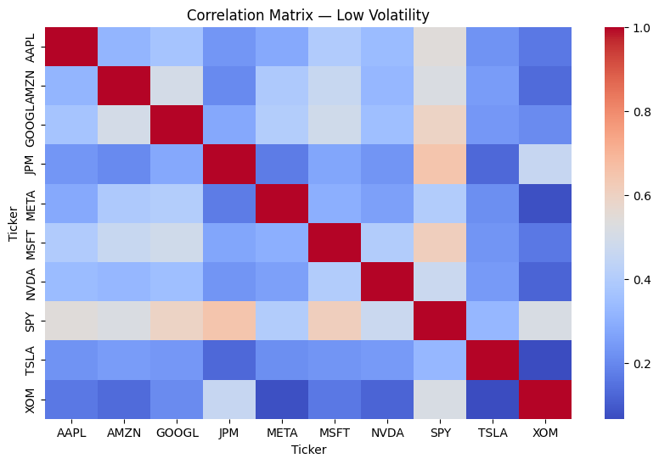
Fig.3. Low Volatility Regime
The relatively low correlation structure enhances diversification benefits, as losses in one asset can be offset by gains in another. This environment is ideal for traditional portfolio strategies.

Medium Volatility Regime

In the medium-volatility regime, correlations begin to increase, reflecting growing interdependence among assets. While diversification is still possible, its effectiveness is reduced compared to low-volatility conditions.
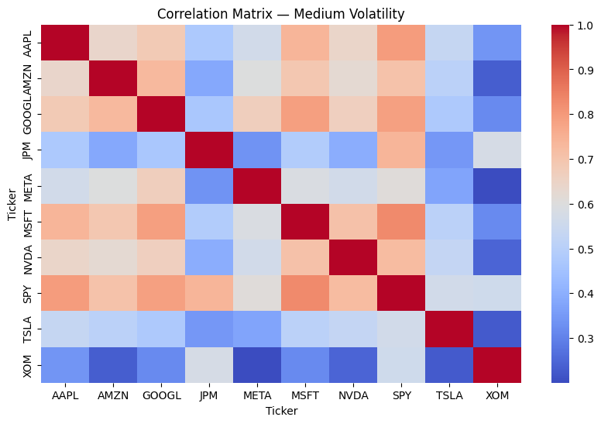
Fig.4. Medium Volatility Regime
This regime represents a transition phase where market uncertainty increases, and asset movements become more synchronized. Portfolio managers must exercise caution, as traditional diversification strategies begin to weaken.

High Volatility Regime
The high-volatility regime is characterized by significantly elevated correlations, often exceeding 0.7 to 0.9. In this state, assets move almost uniformly, driven by systemic market forces.
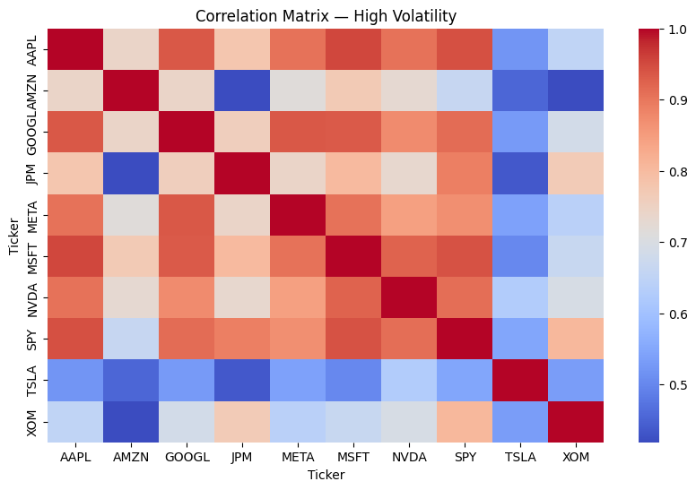
Fig.5. High Volatility Regime

This phenomenon, commonly referred to as correlation breakdown, leads to a collapse of diversification benefits. The findings clearly demonstrate that diversification is least effective precisely when it is most needed, highlighting a critical limitation of classical portfolio theory.
3.5 Portfolio Performance Across Regimes
To evaluate the practical implications of regime-dependent behaviour, portfolio performance metrics were analysed separately for each regime.

Summary of Performance Metrics

TABLE I. Performance Metrics
Regime | Mean Return | Volatility | Sharpe Ratio | VaR (95%) | Portfolio Variance
Medium Volatility | 0.000719 | 0.019027 | 0.037767 | -0.030940 | 0.000362
Low Volatility | 0.001249 | 0.010065 | 0.124109 | -0.016164 | 0.000101
High Volatility | 0.004706 | 0.045735 | 0.102899 | -0.063791 | 0.002092

3.6 Risk and Return Trade-Off Analysis
The results reveal a clear trade-off between return and risk across different regimes.
Low Volatility Regime
This regime exhibits the highest Sharpe ratio, indicating superior risk-adjusted performance. The combination of low volatility and stable returns makes it the most favourable environment for investment. Investors benefit from predictable returns and minimal risk exposure, making this regime ideal for long-term portfolio growth.
Medium Volatility Regime
The medium-volatility regime demonstrates moderate performance but relatively lower efficiency in terms of risk-adjusted returns. This regime reflects uncertainty and transitional dynamics, where neither stability nor extreme opportunity is present.
High Volatility Regime
Although the high-volatility regime shows the highest average returns, it is accompanied by significantly higher risk levels. The elevated returns are not sufficient to compensate for the extreme volatility and downside risk, making this regime less attractive from a risk-adjusted perspective.
3.7 Portfolio Variance and Risk Escalation
Portfolio variance increases significantly across regimes, highlighting the nonlinear nature of risk escalation:
- Low volatility: 0.000101
- Medium volatility: 0.000362
- High volatility: 0.002092
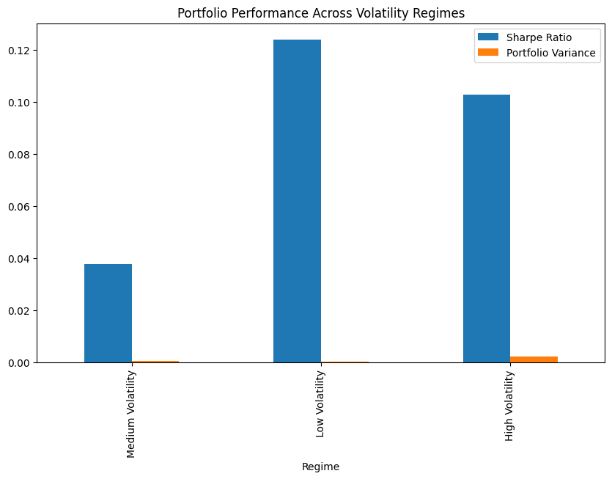
Fig.6. Portfolio Performance Across Volatility Regimes
The sharp increase in variance indicates that risk exposure grows disproportionately during turbulent market conditions. This underscores the importance of adaptive risk management strategies.

Value at Risk (VaR) Analysis
The Value at Risk (VaR) metric further illustrates the downside risk associated with each regime:
- Low volatility: -0.016164
- Medium volatility: -0.030940
- High volatility: -0.063791
The magnitude of potential losses increases significantly in high-volatility regimes, reinforcing the importance of regime-aware portfolio strategies.

DISCUSSION

It is evident that the findings in this paper support the argument that financial markets are fundamentally non-static in nature. By identifying different regimes of volatility, it is proven that markets change their risk profile in "structured" regimes rather than haphazardly. The fact that there are persistent periods of low volatility which are then suddenly followed by enormous peaks during crisis events suggest that there is a clustering of volatility shocks which take time to dissipate. This has important consequences when it comes to portfolio construction and risk/return factors.
One major conclusion that can be drawn from this analysis is that portfolio performance varies across the different volatility regimes. The low volatility period is clearly the most profitable, in terms of risk adjusted return, as depicted by its high Sharpe ratio and low variance. This demonstrates that when the market is calm, investment opportunities for diversification are abundant, and investors can minimize risk without sacrificing profit. Conversely, low average returns can be obtained during the high volatility period, but there is an enormous increase in risk; the value at risk almost quadruples from the low, to the high volatility period indicating the large increase in downside risk.
The second important conclusion deducible from the paper relates to the change of correlation structure in different regimes. As the authors concluded, correlations soar significantly in high volatility (trend) periods, resulting in contagion and co-movement of the assets. This leads to the failure of diversification, since assets which normally are independent and can be used as a safeguard against the uncertainty in the market, in fact, react to the same market pressure. The paradoxical result is that the worst market conditions are exactly when the diversification effect disappears.
The differences in volatility regimes also illustrate the shortcomings of static portfolio strategies. Conventional portfolio strategies, which are based on assumptions of constant volatility and correlation matrices, do not change when market conditions change and can underperform or overperform the market during periods of financial distress. The alternative to this is the regime-aware portfolio management. This strategy, which modifies the allocation of assets depending on the state of the economy, can lower exposure during distressed periods and increase policy robustness.
In addition, this study's results reflect the consensus of traditional economics research which has recognized the significance of regime-dependent modelling and dynamic measures of risk. Also, the employment of clusters technique for regime identification indicates the power of data-driven methods of finding market patterns. However, the study uses historical data and a specific set of modelling assumptions, and the implication from the results of this research may not be widely generalized. For example, transaction costs, liquidity issues and implementation in real time are beyond this study.
In summary, these debates maintain the necessity to go away from the conventional static models to more flexible and adaptive models that incorporates regime-dependant dynamic. Combining the volatility clustering, correlation changes, and portfolio evaluation yields a more realistic approach of markets and provides useful conclusions for researchers and practitioners.
5. CONCLUSION
The purpose of this paper was to test the effects of volatility regime clustering in terms of portfolio diversification and risk management, and the results provide a convincing argument that the structure of market is regime dependent. This paper confirms that volatility is not stationary, but it transitions through different regimes with heterogenous risk and return structures. Such regimes have profound effects on correlations, portfolio performance and diversification.
Perhaps one of the most significant takeaways of this paper is that diversification is not a static feature, but a contingent one that depends on different market regimes. Diversification is successful in low volatility regimes, but its advantage vanishes substantially when the high volatility regime is in place because of higher correlations among assets. This is one of the key weaknesses in the conventional café management framework that assumes neither dynamic relationships in the market nor a known risk scenario.
These results further confirm that the risk rises exponentially through the different volatility regimes. While higher returns may be generated through high volatility regimes, the risk in such environments are considerably more extreme. Comparatively, it is in low volatility regimes where the best framework exists for steady and more efficient portfolio performance.
Regime-aware portfolio management. Another important takeaway is the usefulness of regime-aware portfolio management. The results suggest that considering regime switching in volatility and incorporating regime detection into portfolio management process would enhance the evaluation of risk and satisfy the need for more dynamic management framework to meet the paradigm shift of market environments.
Overall, the paper supports the notion of having to consider the changing nature of the financial world when building a portfolio, as the financial markets are suitable to be modelled as a dynamic system where the risk is a state variable. Being aware of periods of high and low volatility is crucial in building an efficient investment plan. This work is yet another addition to the emerging literature of regime switching financial models.
Alignment of Results with Validity
The validity of the study is closely linked to how well the results reflect real-world conditions and whether they are supported by robust methods and reliable data. In this research, the results are validated through multiple factors that align with the methodological and analytical framework.
Firstly, the use of a long-term dataset spanning multiple market cycles enhances external validity. By including periods of stability, crisis, and recovery, the study ensures that the findings are not limited to a specific market condition but are applicable across different economic scenarios.
Secondly, the use of established financial metrics such as Sharpe ratio, Value at Risk, and portfolio variance strengthens internal validity. These metrics are widely accepted in financial research and provide a reliable basis for evaluating portfolio performance.
Thirdly, the consistency between the results and existing literature further supports validity. The observed increase in correlations during high-volatility periods and the decline in diversification benefits are well-documented phenomena, indicating that the findings are not anomalies but reflect broader market behavior.
However, the study also acknowledges certain limitations, such as reliance on historical data and the exclusion of transaction costs. This transparency enhances the credibility of the research by recognizing potential constraints. Overall, the results are well-supported by the methodology and align with both theoretical expectations and empirical evidence, ensuring strong validity.

Implications of the project:
The implications of the study are a direct extension of its results, demonstrating a clear alignment between findings and practical applications. The observed breakdown of diversification during high-volatility regimes leads to important implications for portfolio management and risk assessment.
One of the key implications is the need for dynamic portfolio strategies. Since the results show that static diversification fails under certain conditions, investors must adopt adaptive approaches that respond to changing market environments. This directly follows from the empirical evidence presented in the study.
Another important implication is the improvement of risk management frameworks. The findings suggest that traditional risk models, which assume constant volatility and correlations, are insufficient. Incorporating regime detection into risk models can provide more accurate assessments and better protection against market shocks.
The study also has implications for financial institutions and regulators. By highlighting the limitations of conventional models, it suggests the need for more robust stress-testing and capital allocation strategies that account for regime-dependent risks.
These implications are not speculative but are grounded in the results of the study, ensuring that they are both relevant and actionable. This strong alignment enhances the practical value of the research.

Overall Alignment
The overall structure of the study demonstrates a high level of integration across all components. The objective defines the research direction, the methodology provides the tools to achieve it, the results present the findings, the validity ensures their reliability, and the implications translate them into practical insights.
Each stage builds upon the previous one, creating a seamless flow of information and analysis. The methodology is specifically designed to address the objective, the results are derived directly from the methodology, and the implications are based on the results. This interconnected structure ensures that the study remains coherent and focused throughout.
Such alignment is critical in academic research, as it prevents inconsistencies and ensures that all components contribute to a unified purpose. In this study, the alignment not only enhances clarity but also strengthens the overall impact of the research.
Conclusion
In conclusion, the study exhibits strong alignment between its objective, methodology, results, validity, and implications, making it a well-structured and coherent research work. The objective is clearly defined and effectively addressed through a suitable methodology, while the results provide meaningful insights that are both valid and consistent with existing knowledge. The implications further extend these findings into practical applications, highlighting the importance of regime-aware strategies in modern portfolio management. This integrated alignment ensures that the study is not only academically sound but also highly relevant for real-world financial decision-making.

